1. Create a Kubernetes cluster in GCP/GKE and deploy a simple spring boot application.

**GCP- Google Cloud Platform**

To deploy a simple Spring Boot Java web app to Kubernetes on GKE.

Cloud Console URL: console.cloud.google.com

1. To enable the Kubernetes Engine API: Go to project selector to select or create a Google cloud project
2. Enable the Artifact Registry and Google Kubernetes Engine APIs by clicking Enable the APIs

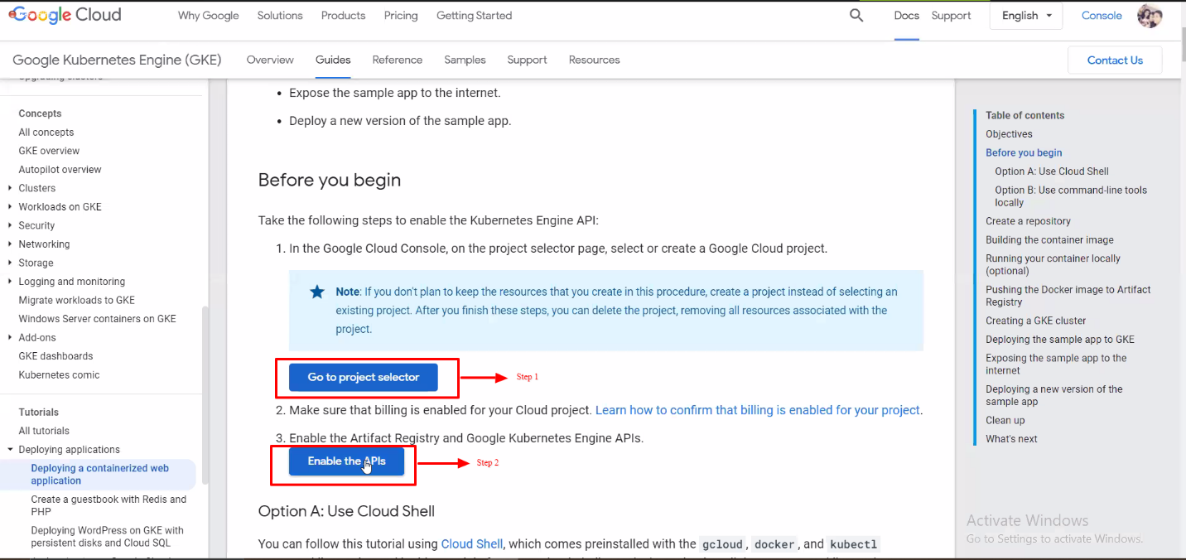

1. Click on next to confirm the project

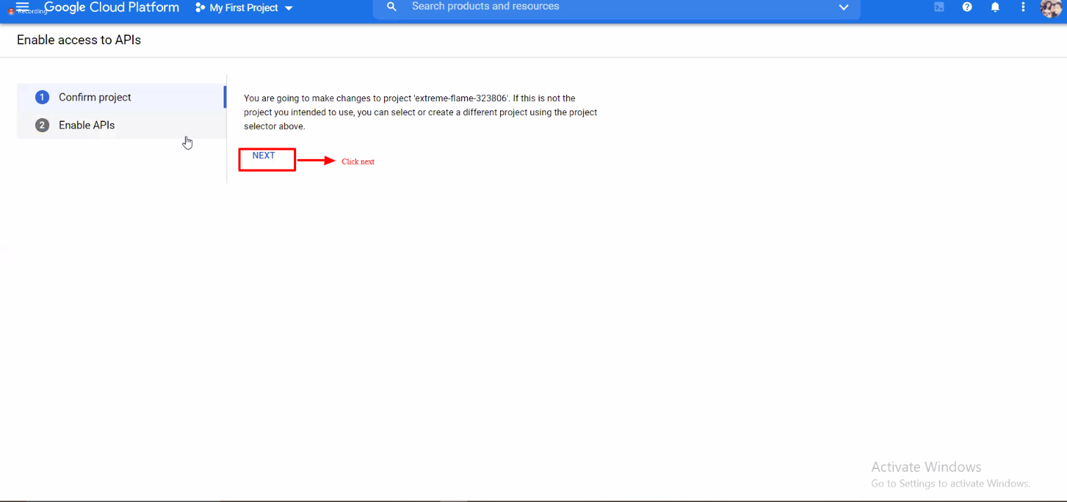

1. Click on Enable to enable the APIs.

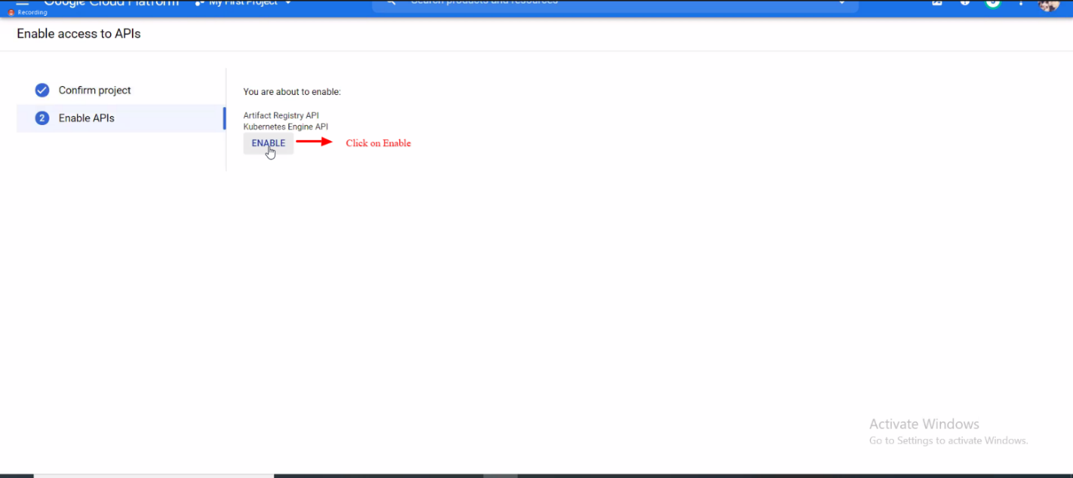

1. Now click on Kubernetes Engine >> Clusters

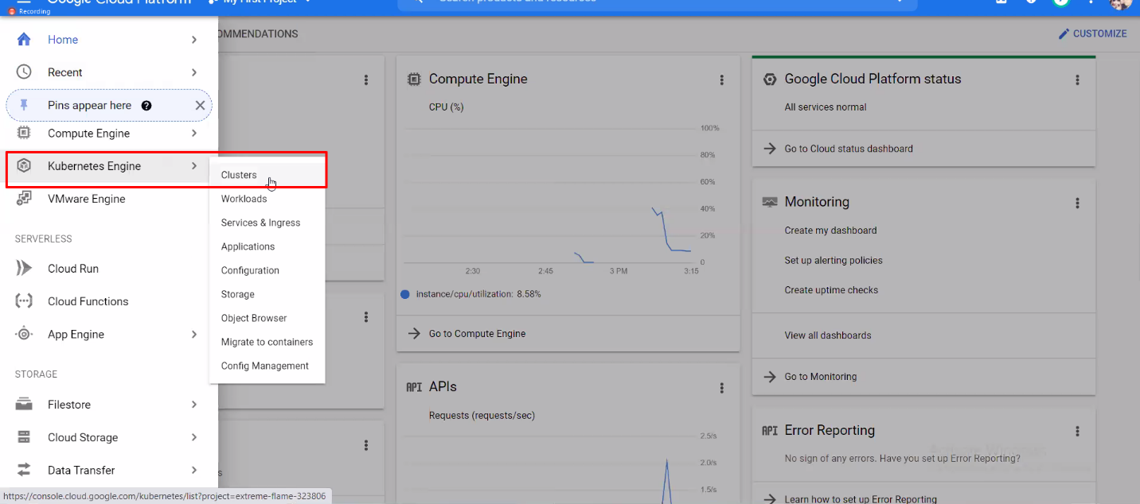

1. Now click on Configure

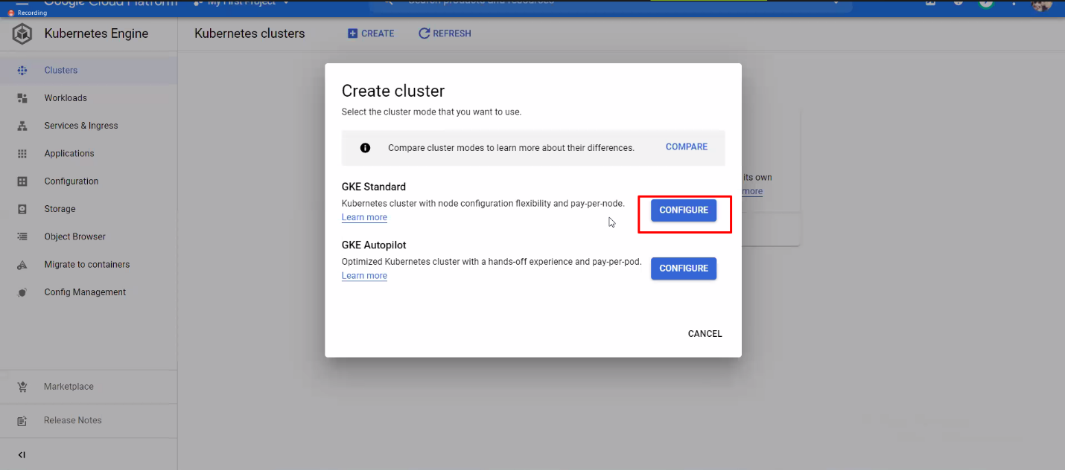

1. Enter the name of the Project and click on create.

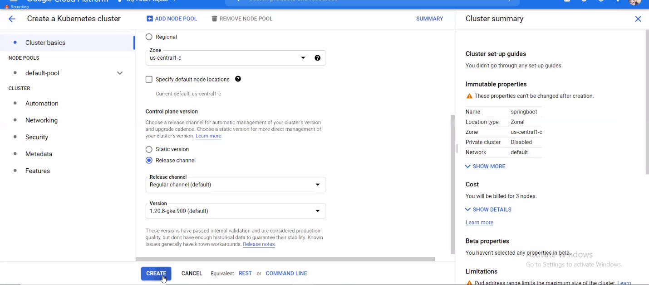

1. Select the project and goes to the Web Preview. Preview on port 8080.

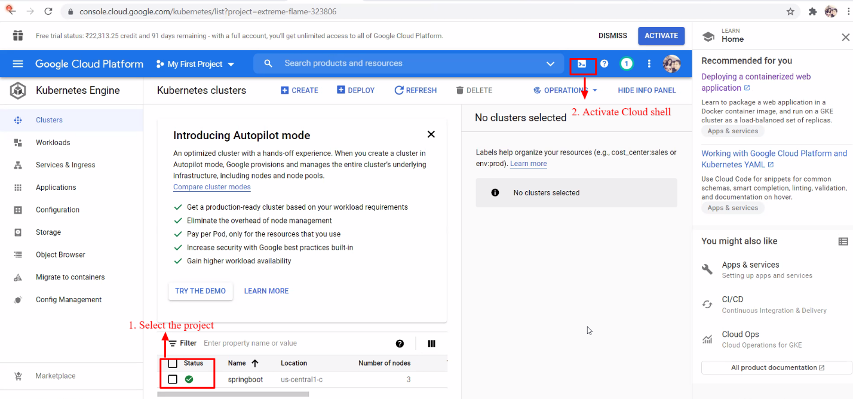

1. Now get the source code

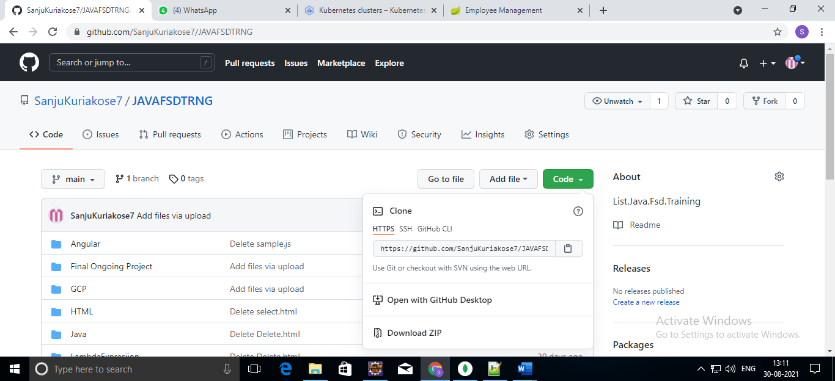

1. Use the command line to clone the source code in the home directory.

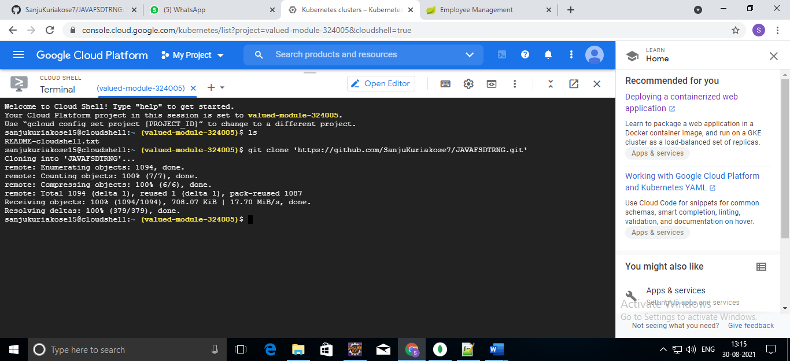

1. To change directory use cd command

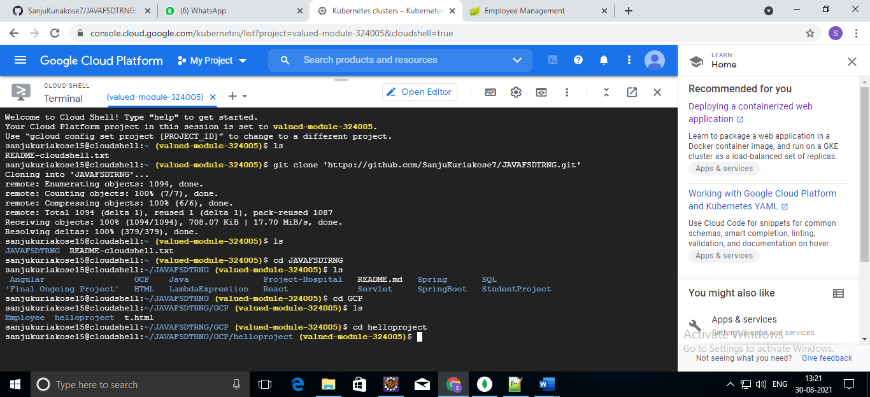

1. To install maven use ./mvnw clean install command

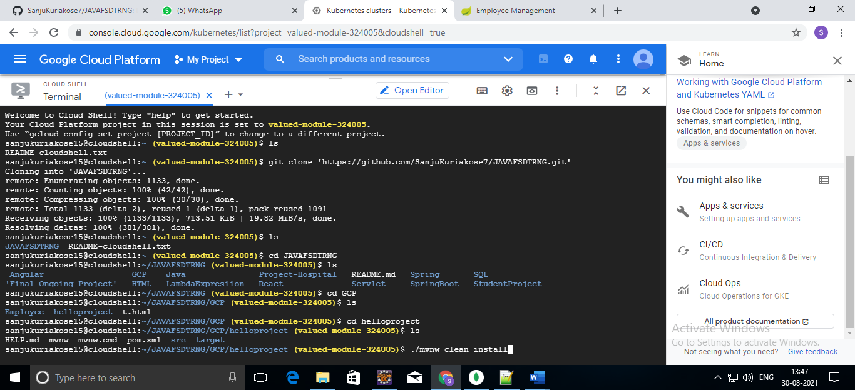



Installation….

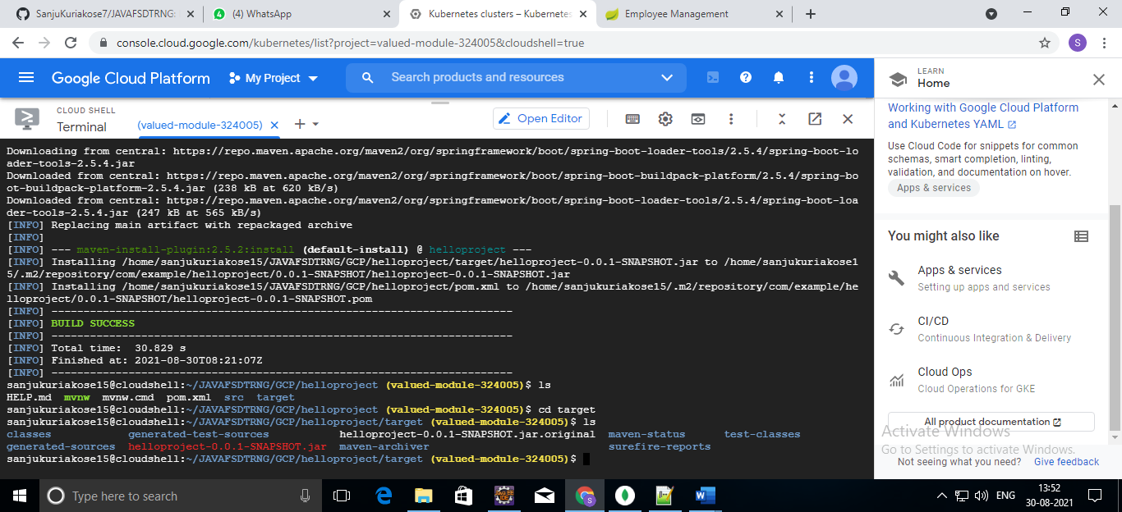

1. To run the project use java -jar

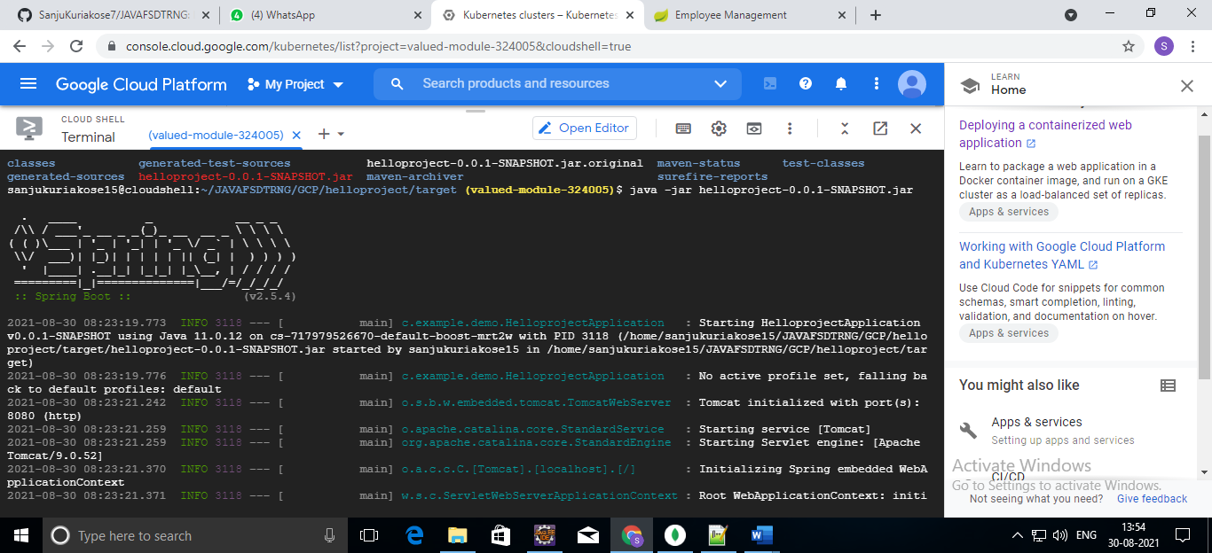



1. A tab in your browser opens and connects to the server you just started.

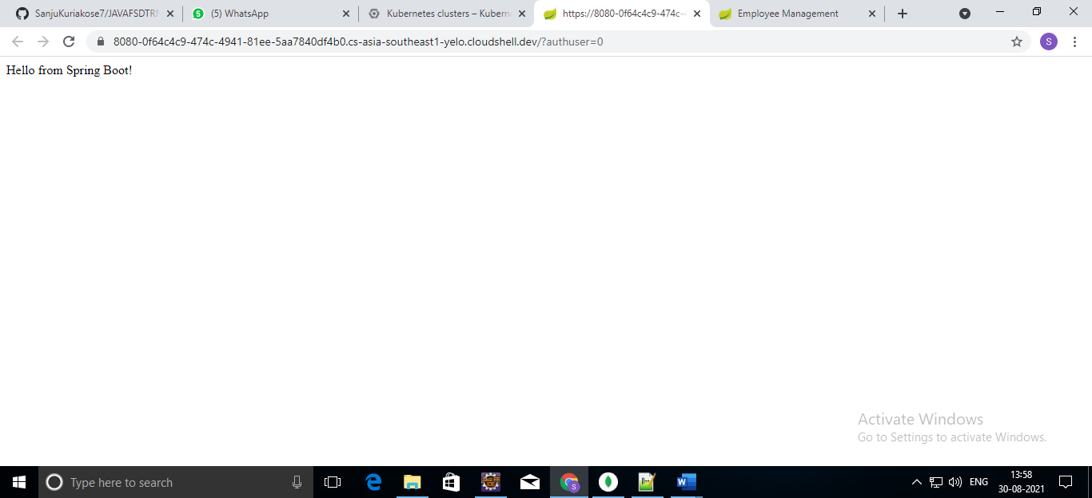

1. Deploy the parallel project (Employee Management portal) onto the GKE.

To deploy a Employee Management Project to Kubernetes on GKE.

Cloud Console URL: console.cloud.google.com

1. Now click on Kubernetes Engine >> Clusters



2.Now click on Configure



3.Enter the name of the Project and click on create.



4.Select the project and goes to the Web Preview. Preview on port 8080.



5.Now get the source code

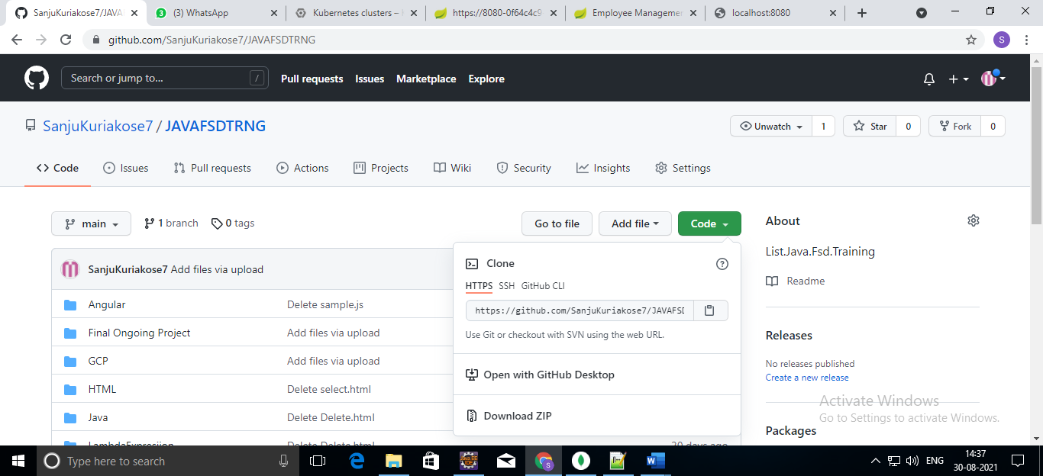

6.Use the command line to clone the source code in the home directory.

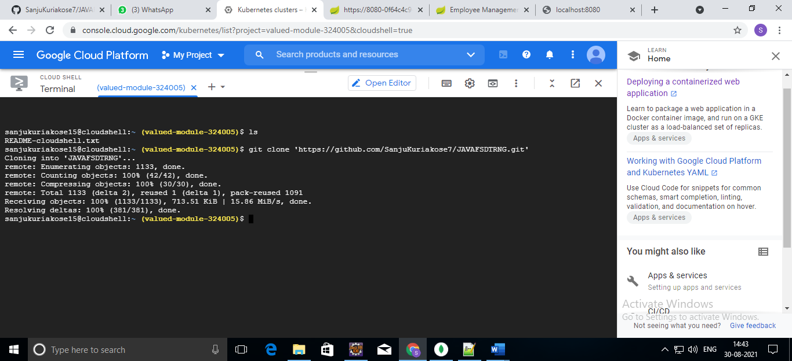

The Employee Management Project is connected with microservice. So There is 2 projec we want to run : SpringA and Springexample2.

SpringA:

7. Use the command ‘cd’ to change the directory

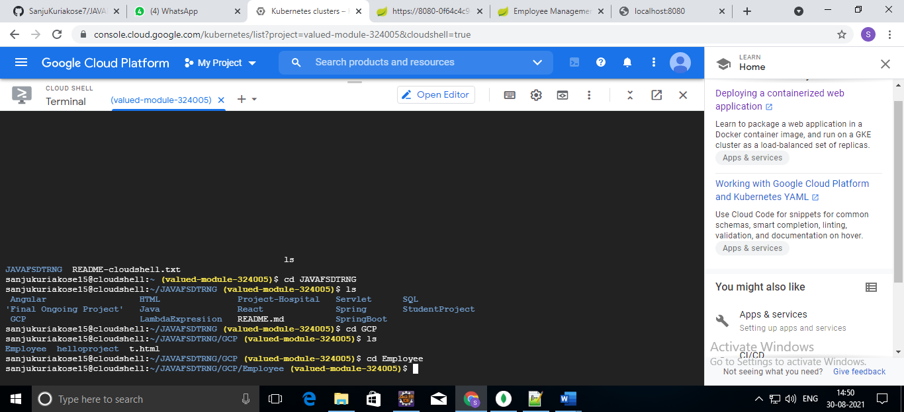

8.Use command line ./mvnw clean install to install maven.

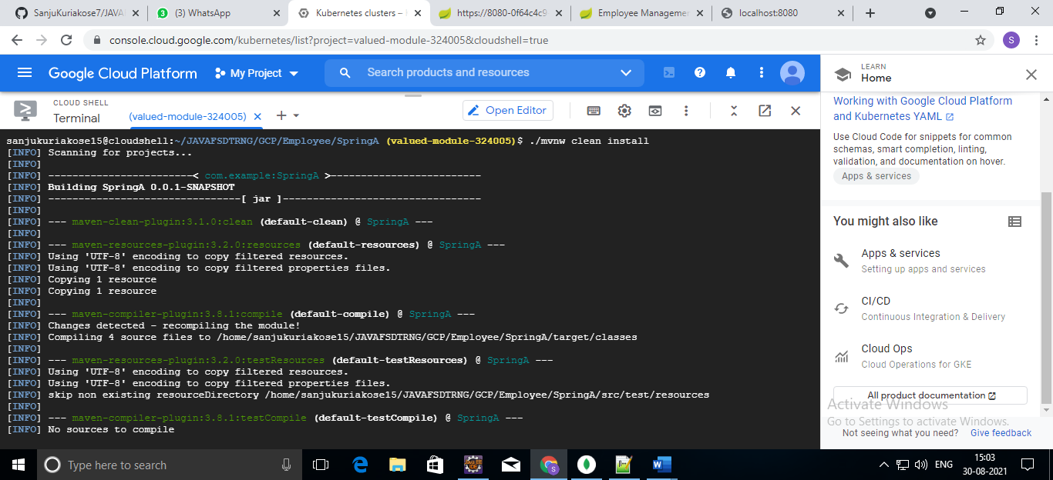

Installation…

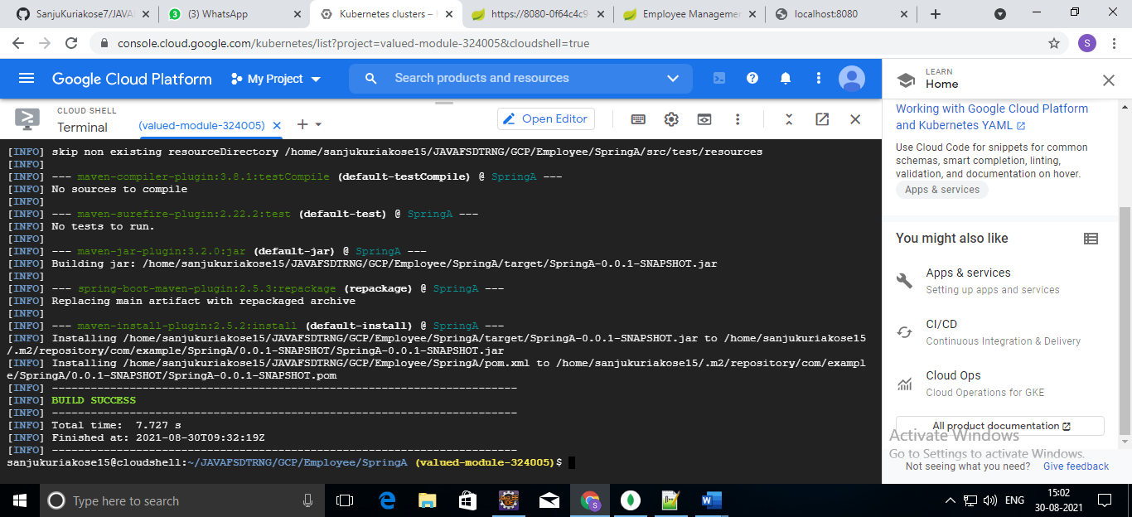

9. To run the Project use the command ‘java -jar’

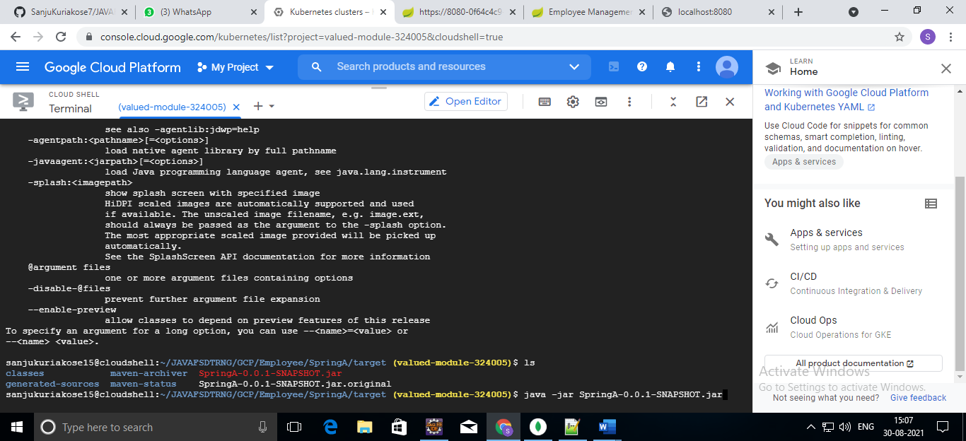



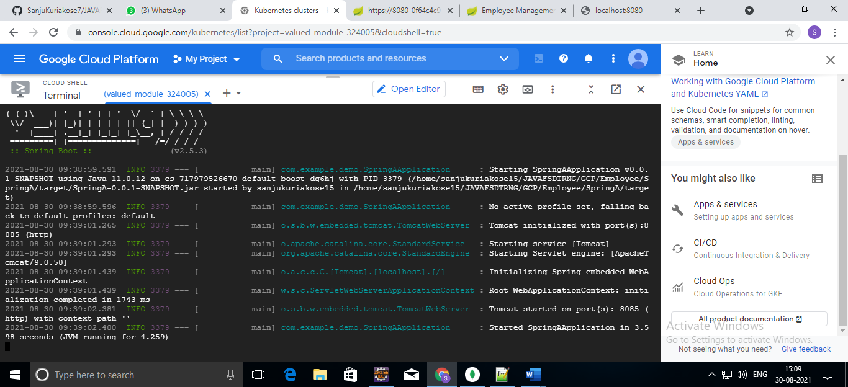

Springexample2:

Take another terminal and follow the above steps to run the Springexample2.

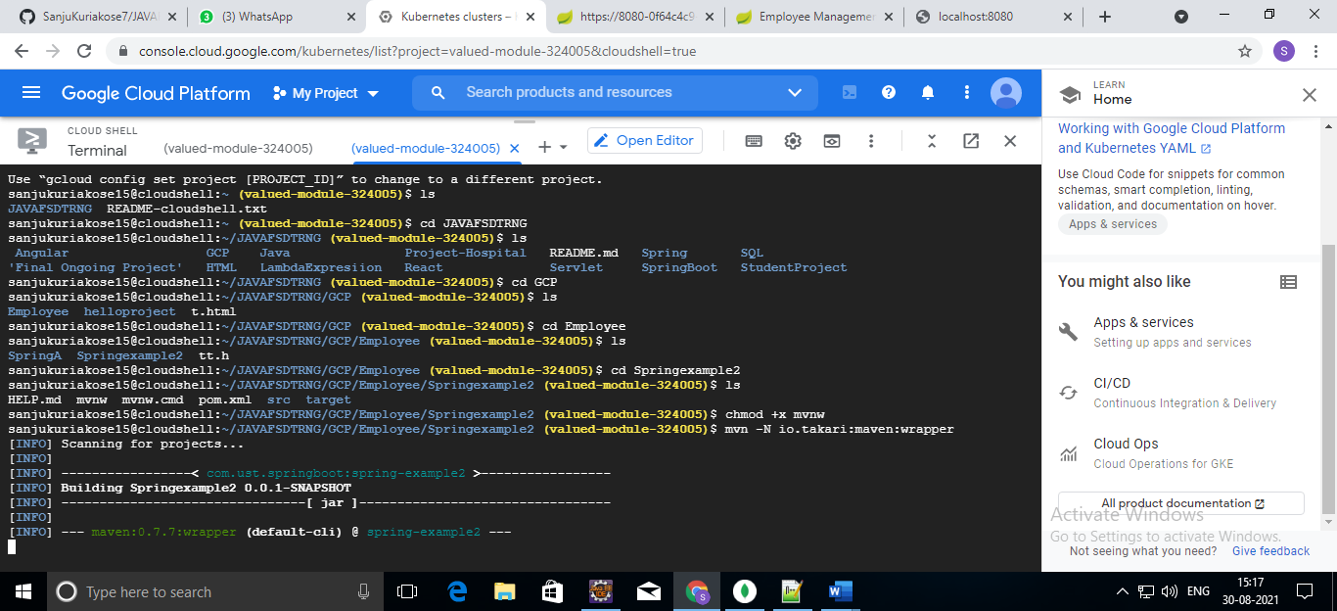

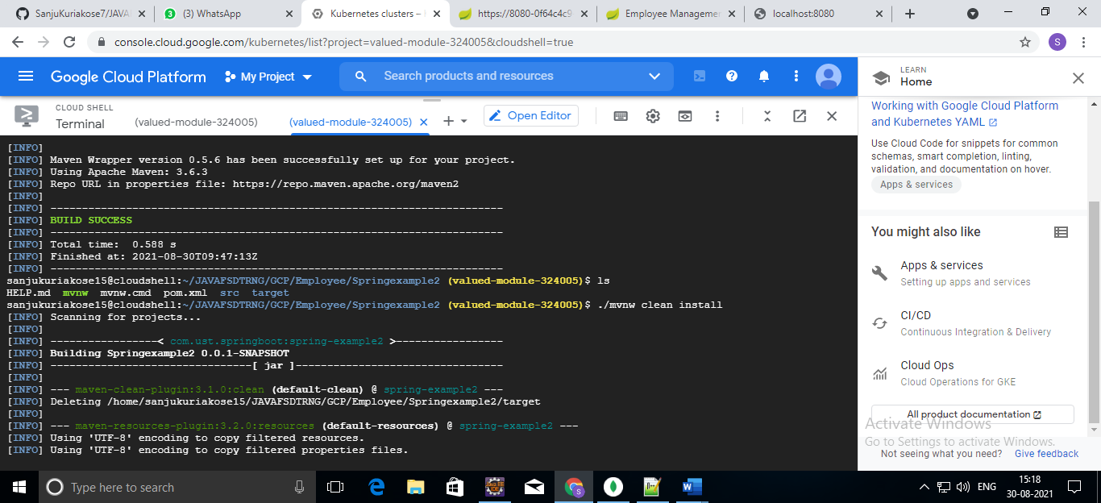

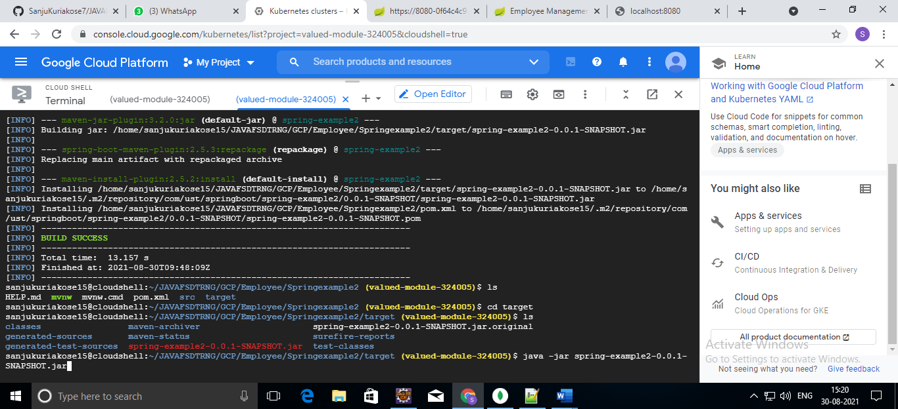

10. A tab in your browser opens and connects to the server you just started.

